**HARDWARE CIRCUIT CONNECTION**

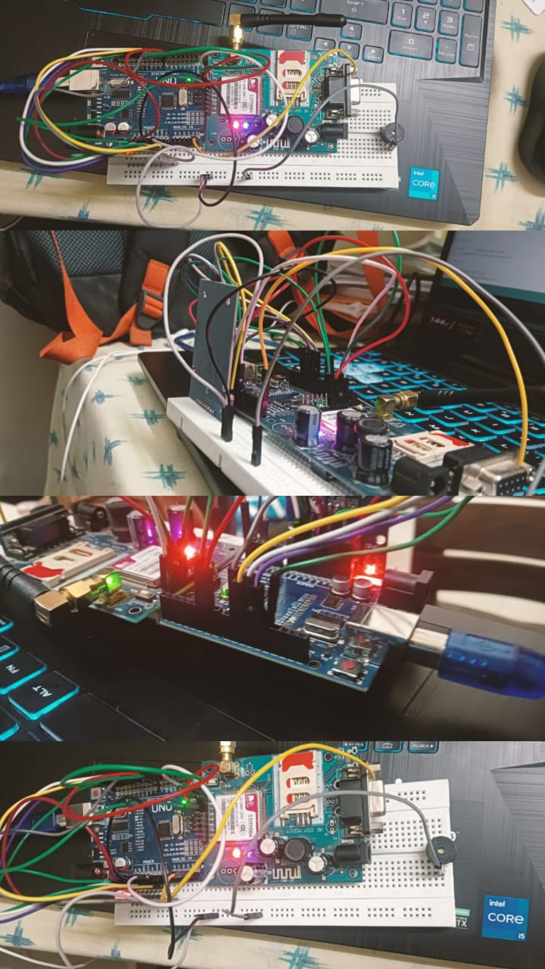

**Flow Charts**

